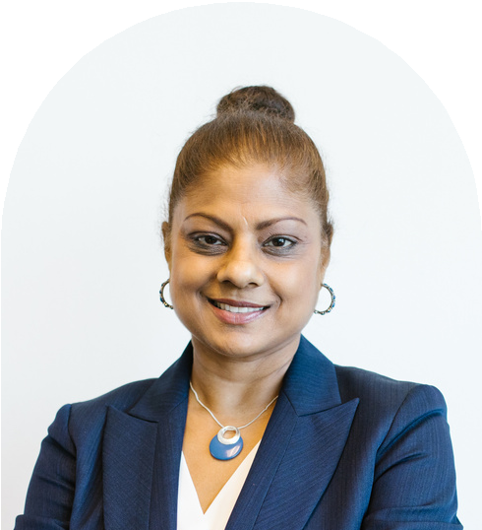
Nisha Kaur
Digital Marketing Executive

Work Experience Contact Info


Digital Marketing Specialist
Pin & Ark Advertising, a global advertising firm that specializes in reaching online audiences
August 2022 to May 2025 (2 years, 9 months) Achieved a 30% increase in social media followers by developing a strong content strategy that led to a 5% growth in sales within six months
Increased B2B and B2C partnerships by 5% by overseeing marketing campaigns from planning to optimisation
Boosted clients' brand recognition by 10% by developing new ideas and content marketing strategies

Sales and Marketing Assistant Suresh Digital Media Group
November 2020 to January 2022 (1 year, 2 months) Increased organic site traffic by 79%. by developing and executing digital marketing content strategies
Increased our client base by 5% by establishing partnerships with advertisers
Worked on sales proposals and online marketing campaigns
LinkedIn Profile: linkedin.com/in/name

hello@reallygreatsite.com
+123-456-789
www.reallygreatsite.com Click here for my portfolio

Relevant Skills

Search Engine Optimization Social Media Management
Web Content Writing

Education History

Master of Science in Marketing Institution: University of Rajasuri Year of Graduation: 2020
Best Thesis
Awardee, Rajasuri Scholarship


Bachelor of Arts in Literature with a Minor in Creative Writing
Institution: Rama University of Arts
Year of Graduation: 2016 Cum Laude
President, Rama University Debate Club 1st Place, 2015 Best Short Story

Contact Info

LinkedIn Profile: linkedin.com/in/name

hello@reallygreatsite.com
+123-456-789
www.reallygreatsite.com Click here for my portfolio

Volunteer Work, Awards, Affiliations and Interests

Volunteer Social Media Coordinator Institution: Shalimar Children's Foundation 2021 to Present
I handle the foundation's social media pages. I also implement online campaigns to drive adoption rates up.

Young Marketer of the Year Award Institution: Talens Marketing Association 2023
I was recognised for my achievements as a role model in brand building, digital marketing and innovation.

Resource Page

Some tips for creating an effective CV

You want your CV to have a link to your Linkedin account and your portfolio site so recruiters can immediately see what you've accomplished.

Add the logo of the companies you have worked in. Link their website or LinkedIn profiles too. Write a short description of what the company does if they are not well known.

Remember to add how long you have stayed in a particular role. Write out the years and months. Example: Jan 2020 to June 2022
(2 years and 5 months).

When writing out your achievements and responsibilities for a job, it is ideal to follow this format: "I have achieved X by doing Y with a result of Z." Quantitative information is highly preferred.

Only list skills you are confident in and are relevant to the job. You may also list specific software or tools that are important to the role.
Adding your photo to a CV is optional. Photos help recruiters remember you, but there is a risk of unconscious bias.

Adding volunteer work and other interests is optional. Information under this section may seem irrelevant but it can build rapport
with recruiters.

Do not crowd your CV. Feel free to use a second page, which usually features your educational background and other achievements and awards.

Make sure the CV's design aesthetic matches the job you are applying for. For creative roles, you may prefer CVs with a touch of color. For more corporate roles, go for a more simple design.

Having a list of references is no longer required in CVs. The same goes for a summary or objective section.

What recruiters usually look for in a CV
Important: Download your CV as a PDF.

In order of importance:
Experience Role or Title
Company's Credibility
Results, Responsibilities, Achievements Portfolio
Contact Information Skills & Relevant Software Educational Background
Volunteering and Other Interests
Do not use docx, png, or jpg since an applicant tracking system may not be able to properly display the file or scan the text.

