Olivia Wilson
Graphic Designer

"Crafting visual stories with creativity, precision, and passion."

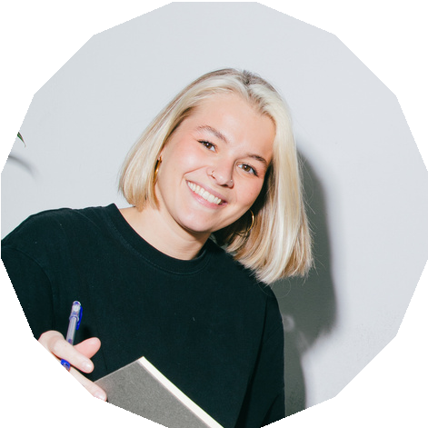Profile
A dedicated and artsy person who strives for the best in works. I have worked with several organizations and led production teams in many projects of every size.

Experience

Graphic Designer (2016-2019)
Responsible for the graphic layouts Edited social media posts and photos

Art Director (2020-2024)
Review and lead the work of the team in the creative production
Manage the content strategy and brand design

Education

School of Design
Bachelor of Design (2012-2016)

School of Design
Master of Design (2017-2019)

Skill

Teamwork Design Photography Illustration Leadership

Contact
+123-456-7890
hello@reallygreatsite.com

